Happy New Year to you all and a big welcome to our new children and parents. We hope you enjoyed the Christmas holidays.  This term our topic is:-  ‘Traditional Tales’ | In Literacy this term we will be:  *Making information books about the people who help us.  *Recognising and over writing our own names  *Learning sounds of letters in our phonics sessions.  * Beginning to write letters.  *Writing a letter and taking it to the post office.  *Carrying out different challenges.  Books/Stories/Rhymes:  - Winter  -The Gingerbread Man  -The 3 Little Pigs  -Goldilocks & the 3 Bears  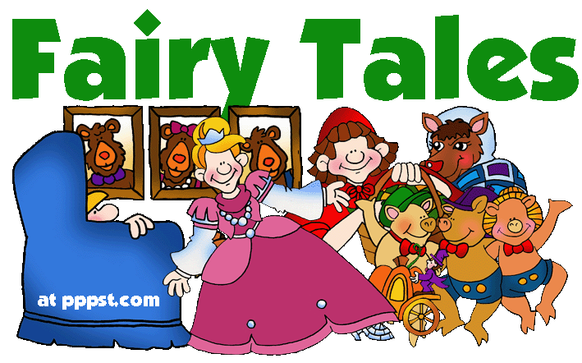  -The 3 Billy Goats Gruff  -Little Red Riding Hood  -5 Little Gingerbread Men  -This Little Piggy |  | How to help at home: Read lots of books and stories with your child. Encourage them to mark make or draw pictures. Encourage your child to hold a pencil using the ‘froggy finger’ grip. Also, you could encourage your child to write some letter shapes with their finger or a pencil, focusing on the letters in their name (please use upper and lower case letters e.g. Harry). Practice the rhyme of the week.  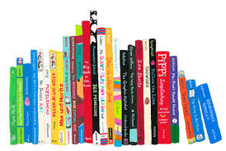
In Communication & Language this term we will be:
* Talking about being helpful
*Having Chatter time
*Taking part in the Every Child a Talker program.
* Learning the rhyme of the week
* Re-telling stories
* Learning to do active listening.

In Expressive Art & Design and Understanding of the World this term we will be:
*Collage Pictures
*Using imaginative language and using a narrative in the Role Play area
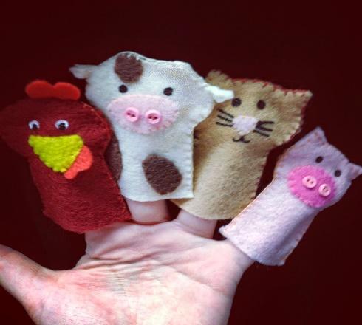
*Splatter painting
*Creating shape snowmen
*Exploring materials
*Making an item to help the gingerbread man cross the river.
*Science activities- best dunking biscuit
*Dressing up
*Having different visitors come and talk to the children.
*Learning about different occupations.

Snack  The children have a healthy daily snack. They can choose a drink of milk or water to accompany it.   | In Numeracy this term we will be:  *Counting to 10+ in 1’s  *Subitising up to 3  *Counting backwards from 5-0 in 1’s  *Ordering by size  *Recognising numbers to 5 and beyond  *Writing numbers to 5 and beyond  *Finding totals  *What comes next?  *Data handling – favourite stories.  How to help at home: Practice writing numbers at home. Number of the week – please practice these with your child – count, write number labels and say the numbers. This will familiarise your child with number recognition and touch counting. Practice adding numbers together – if I have 3 sweets and you have 2 sweets, how many altogether?  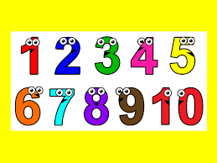 | Enrichment  If anyone would like to come and talk to the children about their job (bus driver, nurse, postman, police officer, vet etc), please speak to Mrs. Grattage or myself.  The children would really enjoy it and it would widen their understanding of the working world.
One of the new children’s targets this term is to put their coat on by themselves and try to fasten it up. Please help your child learn to put on and zip/button up their own coats ☺ As part of our pledges we will be focusing on our manners and saying, ‘please and thank you’.

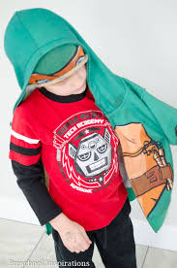

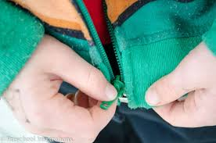

Dates for your Diary
Term ends on Friday 16th February

Nursery re-opens on Monday 26th February

Monday is rhyme day (I will put the rhyme on Classdojo).
Thursday is number day (we are focusing on the numbers 1-5).

Wednesday is phonics based (I will put the focus on ClassDojo).


