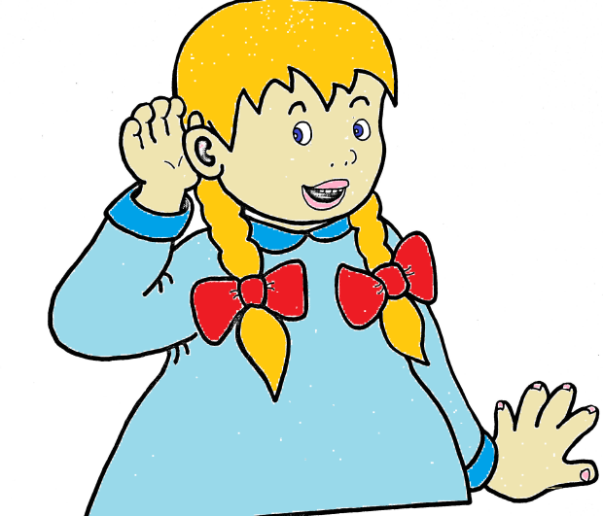
a-e
ai ay

make |  | rain |  | play
made |  | main |  | day
cake |  | wait |  | stay
bake |  | tail |  | pay
shake |  | rail |  | way
shade |  | sail |  | may
rake
pale

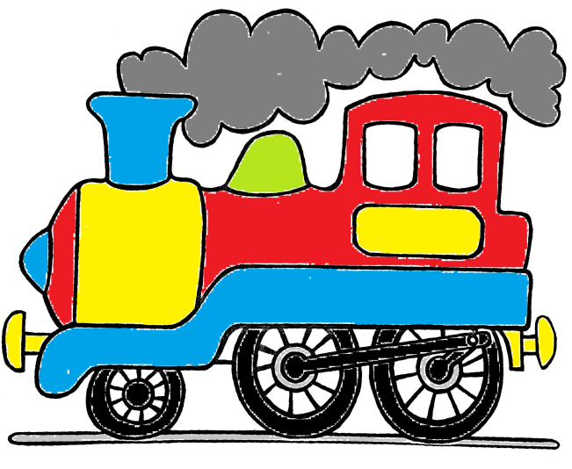
ch

chop |  | chomp
chip |  | chin
church |  | chick
much |  | chuck
such |  | rich

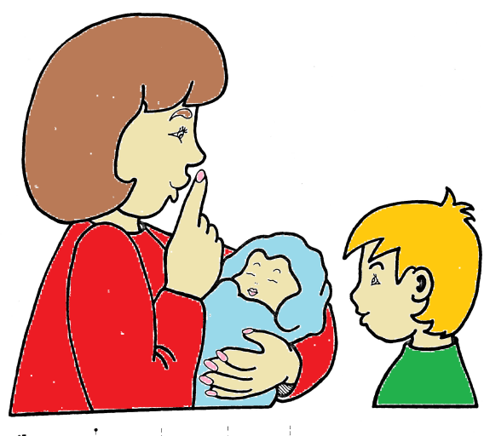
sh

shop |  | fish
ship |  | dish
shut |  | shell
shed |  | shot
wish |  | shall

sh
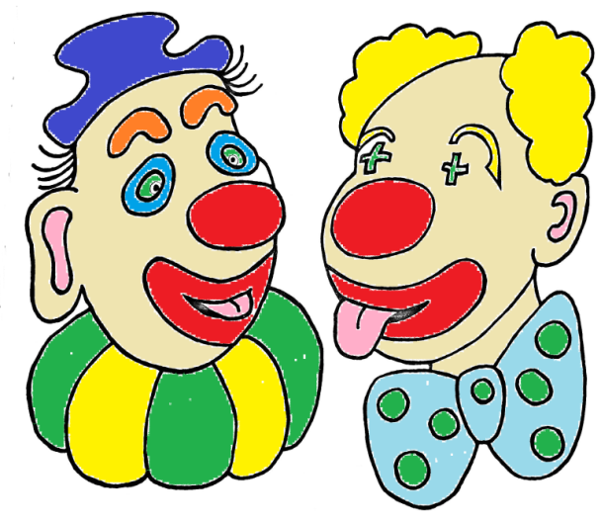
th

think |  | bath
than |  | this
moth |  | that
thin |  | then
thing |  | both

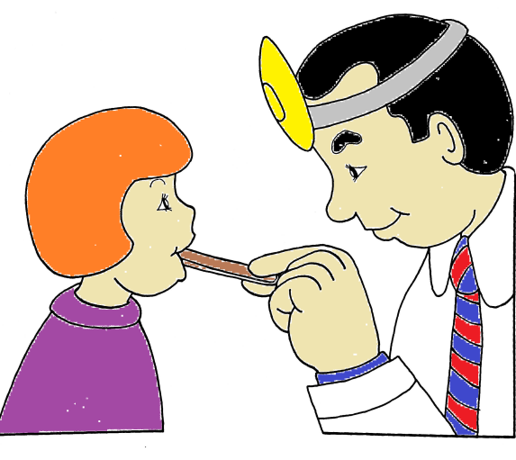
ar

car |  | arm
far |  | sharp
star |  | park
bar |  | shark
farm |  | bark

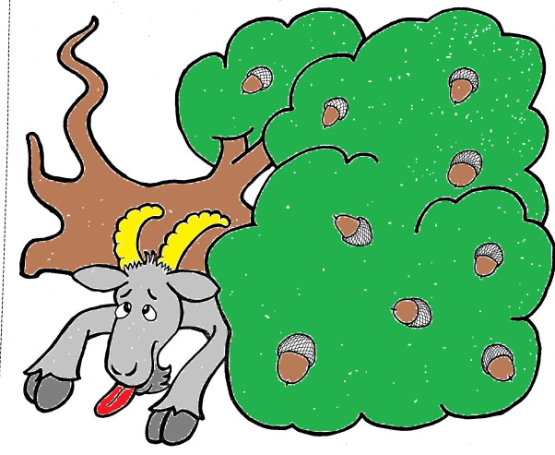

oa

goat |  | road
boat |  | load
float |  | toad
soap |  | foal
oak |  | moan

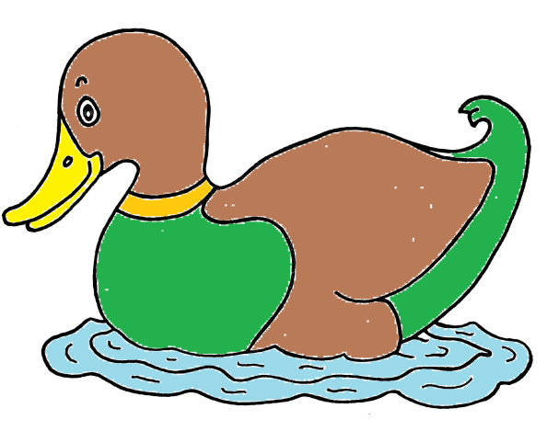
qu

quick |  | squash
quack |  | squeak
quit |  | queen
queen |  | squeal
squid |  | quiz

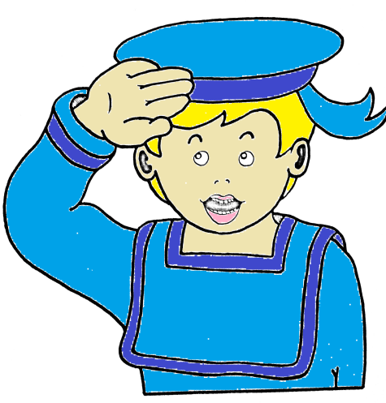
igh y
i-e ie

high |  | shy |  | bike
fight |  | why |  | like
tight |  | lye |  | mine
might |  | sky |  | fine
sigh |  | fly |  | ride
light |  |  |  | side
night |  |  |  | time
 |  |  |  | wipe

lied
cried
tie
pie

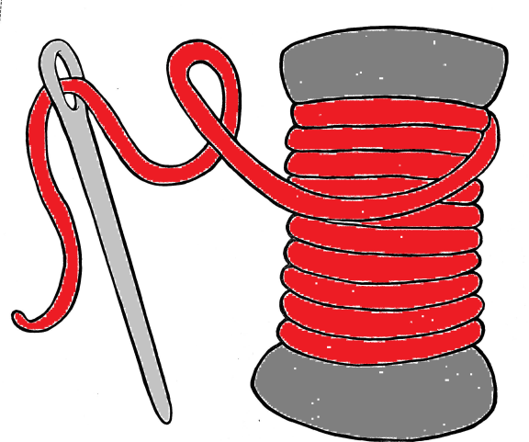
ou ow

out |  | cow
shout |  | now
sour |  | owl
our |  | down
found |  | brown
ground |  | crown

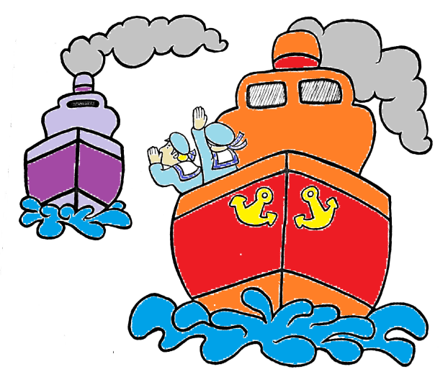
oi oy

boy |  | coin
toy |  | oil
joy |  | point
foil |  | soil

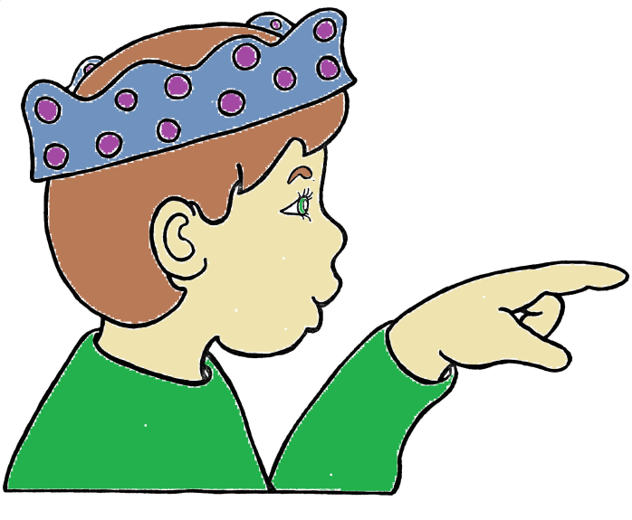
u-e ew
ue

tune |  | few |  | true
cube |  | grew |  | blue
tube |  | blew |  | glue
rude |  | flew |  | clue
June |  | stew
 |  | crew
 |  | new
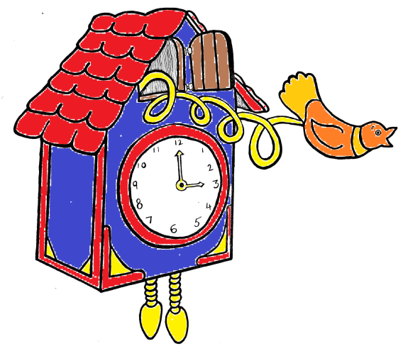
oo

look |  | loom
cook |  | moon
hook |  | spoon
took |  | soon
hood |  | room

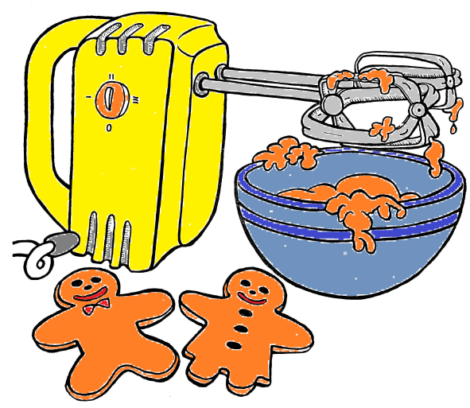
ur er
ir

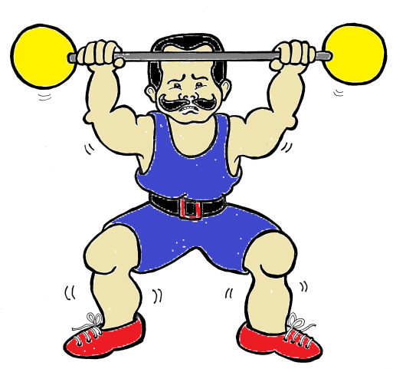
her |  | fur |  | first
boxer |  | hurt |  | skirt
summer |  | murmur |  | shirt
letter |  |  |  | third
runner |  |  |  | flirt
jumper
winter
sing |  | string
sting |  | stung
ring |  | sang
bang |  | strong
thing |  | song
ng

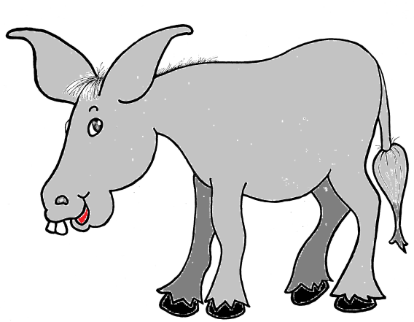
ee ea

see |  | sea
bee |  | pea
meet |  | neat
greet |  | seat
peep |  | speak
steep |  | seal
sheet |  | deal

or aw

for |  | saw
fork |  | paw
form |  | claw
born |  | draw
corn |  | raw

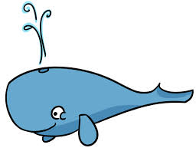
wh ph

whale |  | phonics
while |  | phone
when |  | dolphin
white |  | photo
which
why

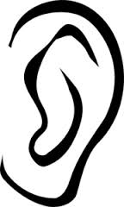
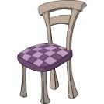
air ear

chair |  | near
stairs |  | fear
hair |  | tear
pair |  | ear
fair |  | clear

Nonsense words

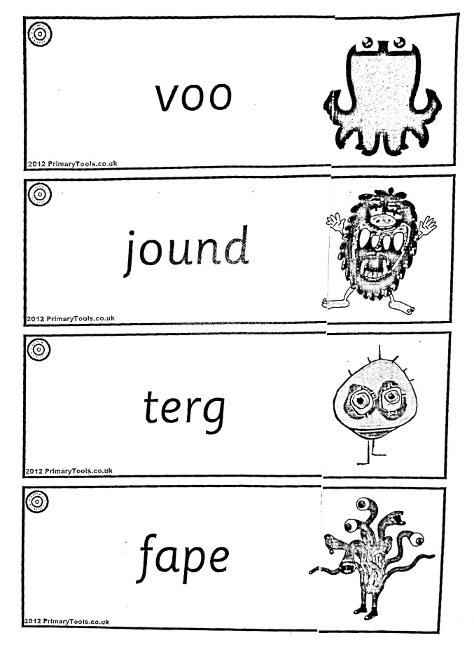
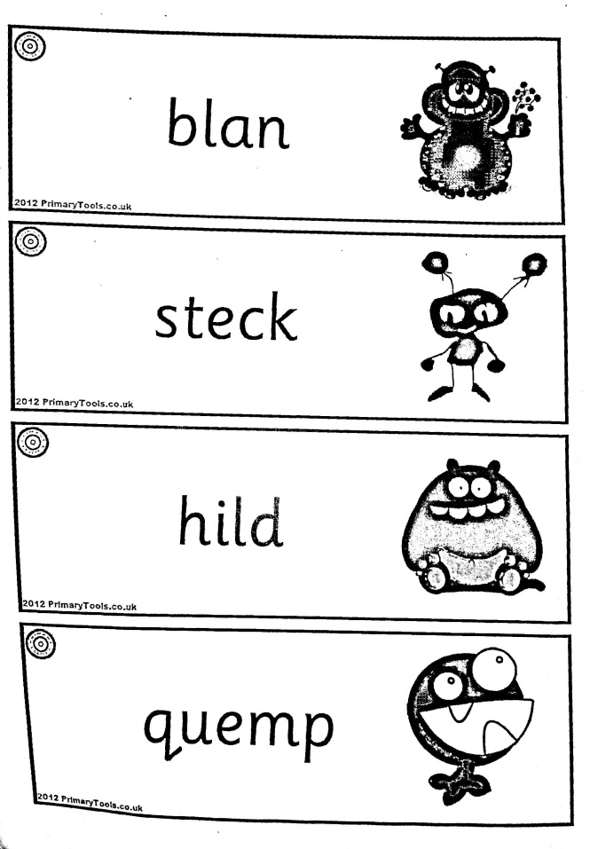

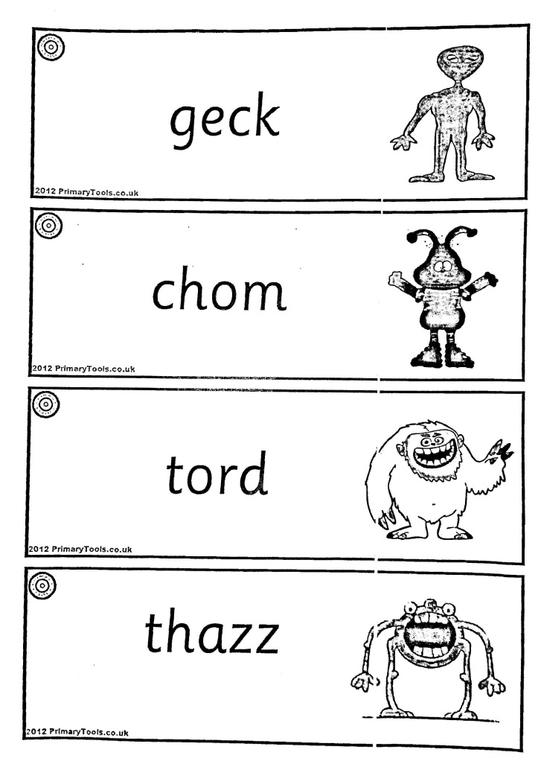
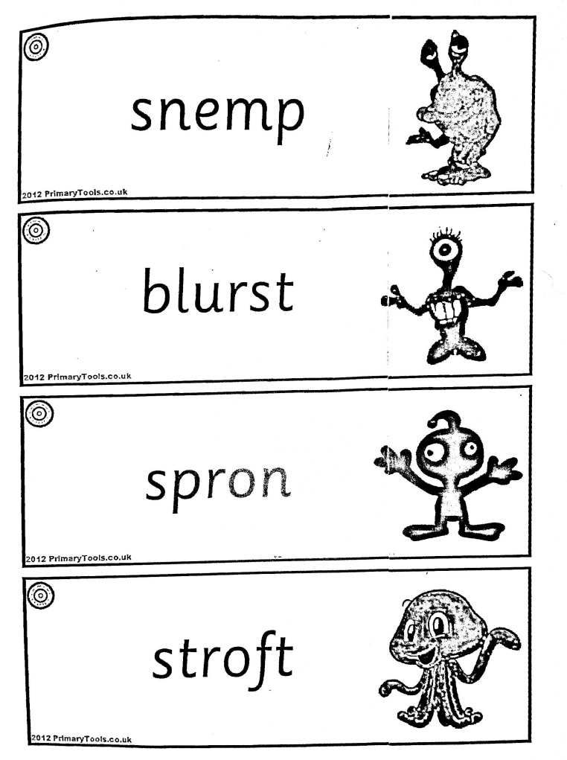

Dear Parents and Carers,

In the summer term your child will be taking part in the ‘National Phonics Screening Check’. The check will ask them to read a list of 40 words, of which some are real, and some are made up. The check is administered like a test and teaching staff do not know what words will come up until they open the paper on the morning of the checks.
In school, your child will take part in daily phonics and literacy sessions, all of which help to build up their phonic knowledge, word recognition and reading fluency. This booklet contains lists of words with the most common sounds in and, you can help your child even further by practising reading the words over the next few terms. You could tick them off when your child consistently reads them correctly. If you would like, you can also practise spelling these words, although this is not necessary for the check.
Thank you for your continued help and support

Annette Lupton

Deputy Headteacher
Literacy Leader

My Phonics
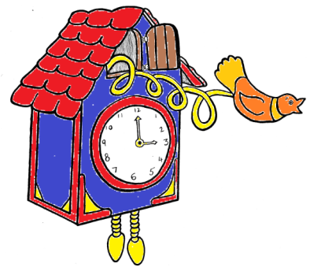
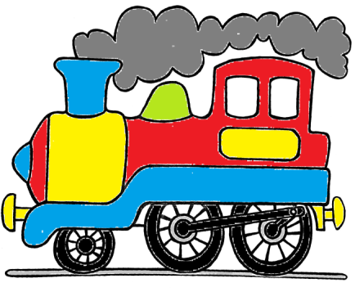
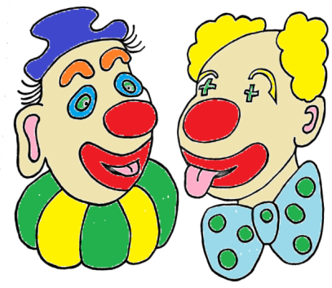
Book

